Part 3: Analysing the data and visualization-

To begin with, we look at some of the basic statistics from the data such as the revenue of the business, number of items sold and data relating to these. One thing to note which will determine how we view the data is that, looking at the sales, it appears that the business is a wholesaler as some transactions involve many bikes of the same (e.g 10 of the same bike). Going forward we will assume that the business is a wholesaler selling to other businesses.

Overall statistics for the business:

Yearly Revenue
Total | Max single  Purchase | Min single  Purchase | IQR | Standard  Deviation | Average  Per Sale
£1058762 | £34000 | £1 | £4428 | £5387 | £3893

From the revenue we can see that average sale is about £3900 and that the spread is quite wide. This, coupled with the IQR shows that a high proportion of sales are clustered around the £2000-£6000. There are some high value outliers up to £34000 which are disproportionate to the average and this could help skew the data. It suggests that the business revenue is propped up by these big sales (the £34000 purchase is 3% of the whole yearly revenue) and is a risk to revenue as these high value sales are probably not the norm. The average suggests that if any sort of general discount was offered for the amount of speeding, to encourage further sales, then it should be offered at levels of £6000/£7000 as this could help push sales to above the average, which could help move some dependencies on high value purchases.

Items Sold
Total | Total Zero Value Sales parts | Revised  Total | Max | Min | IQR | Standard  Deviation | Average
1681 | 162 | 1519 | 10 | 1 | 5 | 2.9 | 5.6

The average of 5.6 indicates that an average purchase typically involves multiple items, with the spread suggesting the majority of sales involve 3-8 items. Since the majority of sales involves multiple items, bulk discount could be considered for larger volume of sales or up-selling. There are 162 items that have a zero value. This could be due to promotional giveaways, replacements or free giveaways for large purchase amounts. It could be useful for the business to investigate this further (for example if it was a promotional giveaway, did it work?).

Items with Most Units Sold
Quantity Revenue
Name Price
HL Mountain Frame - Black 46 1349.60 24 32390.40
Lock Ring 829.80 20 16596.00
Hex Nut 4 158.00 18 2844.00
Mountain-500 Silver 48 564.99 18 10169.82
Handlebar Tube 636.80 17 10825.60
Hex Nut 22 76.40 17 1298.80
LL Road Seat/Saddle 27.12 17 461.04
Flat Washer 5 417.60 16 6681.60
Fork End 397.20 16 6355.20
ML Mountain Frame - Black 48 348.76 16 5580.16

We see that parts (including frames) make up the majority of the most sold items and that only one entry of a bike makes the top 10. If this is typical of the business, then this implies that parts are the items that move the most throughout the year.

Highest revenue generating items -
Revenue Quantity
Name Price
Mountain-100 Silver 38 3399.99 47599.86 14
Road-150 Red 48 3578.27 42939.24 12
Road-150 Red 44 3578.27 39360.97 11
Mountain-200 Black 38 2294.99 36719.84 16
HL Mountain Frame - Black 46 1349.60 32390.40 24
Mountain-100 Black 42 3374.99 26999.92 8
Road-150 Red 52 3578.27 25047.89 7
Touring-1000 Blue 50 2384.07 23840.70 10
Road-350-W Yellow 40 1700.99 23813.86 14
Mountain-100 Black 38 3374.99 23624.93 7

As expected, complete bike sales make up the highest valued items by revenue with mountain bikes and road bikes being the core revenue generators. We see that HL Mountain Frame - Black 46 is a high revenue, high selling item which is not a complete bike but rather it is a frame. This potentially puts it as a key item in the inventory for the reason it acts as to diversify the core products the business offers. The business relies on sales of bikes to produce the bulk of its revenue but moves a lot of other products (parts), again this is healthy as it shows diversity in the products customers are willing to buy and potentially an area of growth in the future due to high demand.

Products with least units sold -

Quantity Revenue
Name Price
Patch Kit/8 Patches 2.29 1 2.29
Womens Mountain Shorts L 69.99 1 69.99
Womens Tights L 74.99 1 74.99
LL Touring Seat Assembly 133.34 1 133.34
Thin-Jam Lock Nut 2 170.00 1 170.00
Blade 189.60 1 189.60
Metal Bar 1 190.80 1 190.80
LL Spindle/Axle 418.40 1 418.40
Mountain-500 Silver 52 564.99 1 564.99

Lowest revenue generating items -

Revenue Quantity
Name Price
Patch Kit/8 Patches 2.29 2.29 1
Bearing Ball 0.80 4.00 5
Mountain Tire Tube 4.99 14.97 3
LL Touring Seat/Saddle 27.12 54.24 2
Womens Mountain Shorts L 69.99 69.99 1
Womens Tights L 74.99 74.99 1
ML Touring Seat/Saddle 39.14 78.28 2
Road Bottle Cage 8.99 80.91 9
LL Mountain Pedal 40.49 80.98 2
Taillights - Battery-Powered 13.99 83.94 6

On the opposite end of the revenue / quantity sold spectrum, we see that clothing is implicated as both low revenue generating and slow moving over the year. The items included within these tables produce negligible revenue and don’t sell in large enough quantities to warrant them to be included as a core item of the business. This implies that these items could be phased out of the business, bundled with other well selling items such as patch kits with bike purchases.
The items within the zero value transactions on inspection were mostly washers, bolts and nuts etc. This could be due to replacement parts, part of a promotion or giveaway and the transaction recorded for inventory reasons.

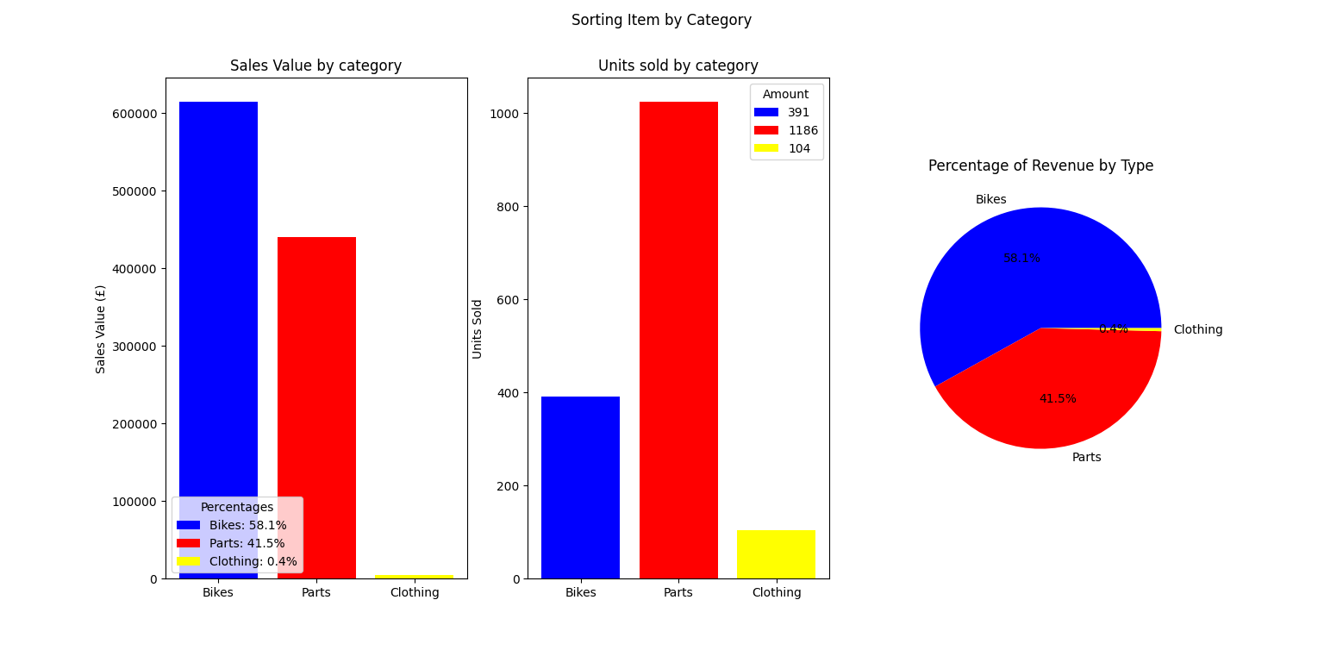
Breakdown of revenue and sales by 3 main item types.

After breaking down the data into 3 main categories, we see that parts is the biggest mover or sells the largest volume and the biggest generator of revenue for the business is the sale of bikes. However parts still generate a significant portion of the revenue which makes it almost as important for revenue as bikes.
Clothing is a very small source of revenue for the business and is potentially an area that needs to be reassessed in how it fits into the business, for example does the stock of clothing take up valuable storage space that would be better served producing and offering other items?. It is also worth considering how and when clothing is sold due to cycling being as generally a seasonal activity.

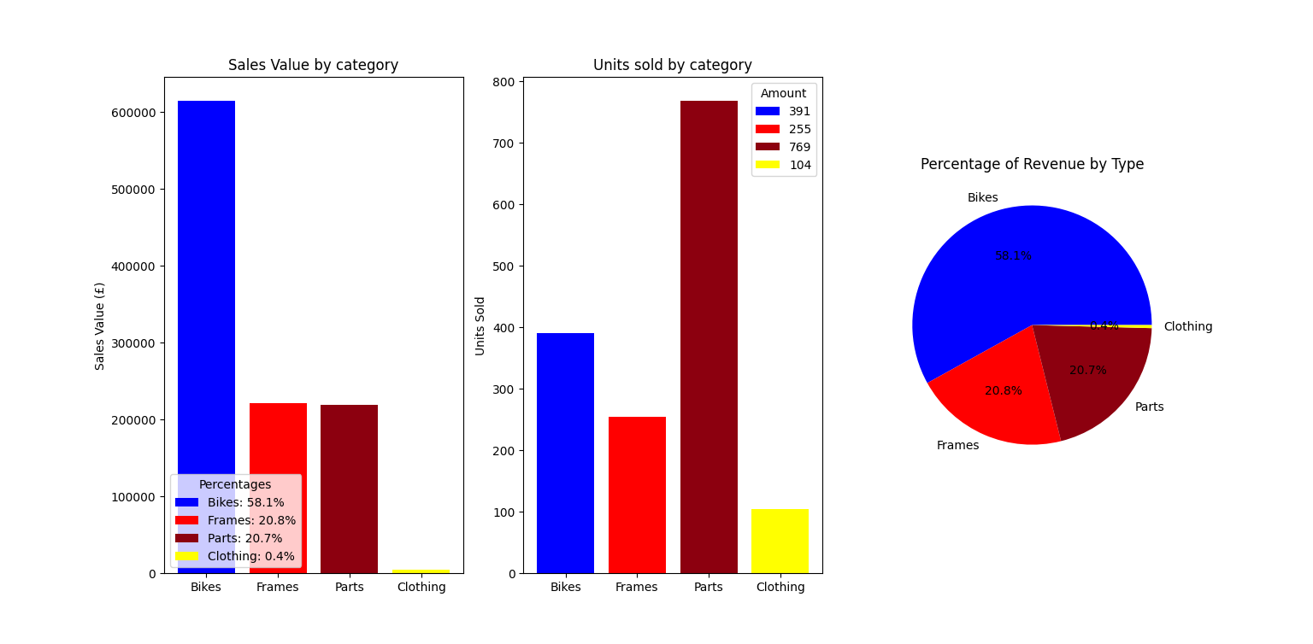
Further breakdown of categories.
Breaking down the data further by extracting frames (keyword frame within the description), we see that actually within the parts category, the sales of bike frames accounts for half of revenue of parts and other parts selling high volume for the same revenue.

Analysis by month

Revenue and sales figures by month -

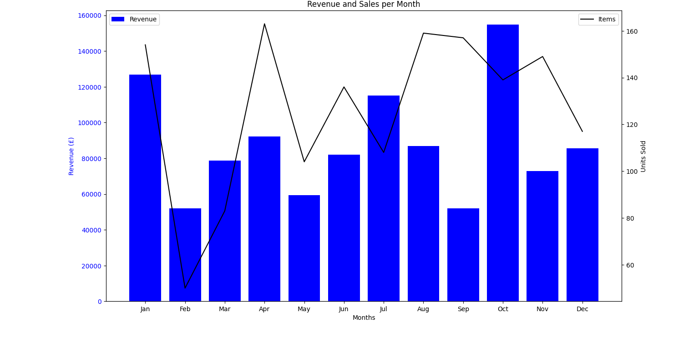Graph of revenue and sales per month

From the data, we see that the number of items sold and Revenue per month follow each other generally. This is to be expected as generally, the more that is sold, the more revenue is made.
Revenue and sales follow these general tends:

1 - In January, there is a large revenue generated, probably from bike sales. This can be explained with a ‘New Years Resolution’ sentiment. That is, as people plan to lose weight or get healthier as a New Years Resolution and cycling being a popular method to do this, it could explain higher sales figures. During this month, this sentiment should be utilized in promotions to ensure that this high revenue event continues every year.

2 - In February, there are little sales and units sold relative to the rest of the year. This could be due to people being ‘spent’ after New Year and demand in cycles in general is low. This month is a prime candidate for boosted promotions , loyalty discounts to customers or offers.

3 - The summer months and winter months produce middle of the road sales and units sold. However, in the months of April, August and September, there are a high number of units sold but lower revenue. This indicates lower value items being sold such as parts.

4 - In October, there is another spike in revenue but with lower units being sold than in April, August and September. This suggests higher valued items, which are likely to be complete bikes. This spike is probably due to the run up to Christmas.

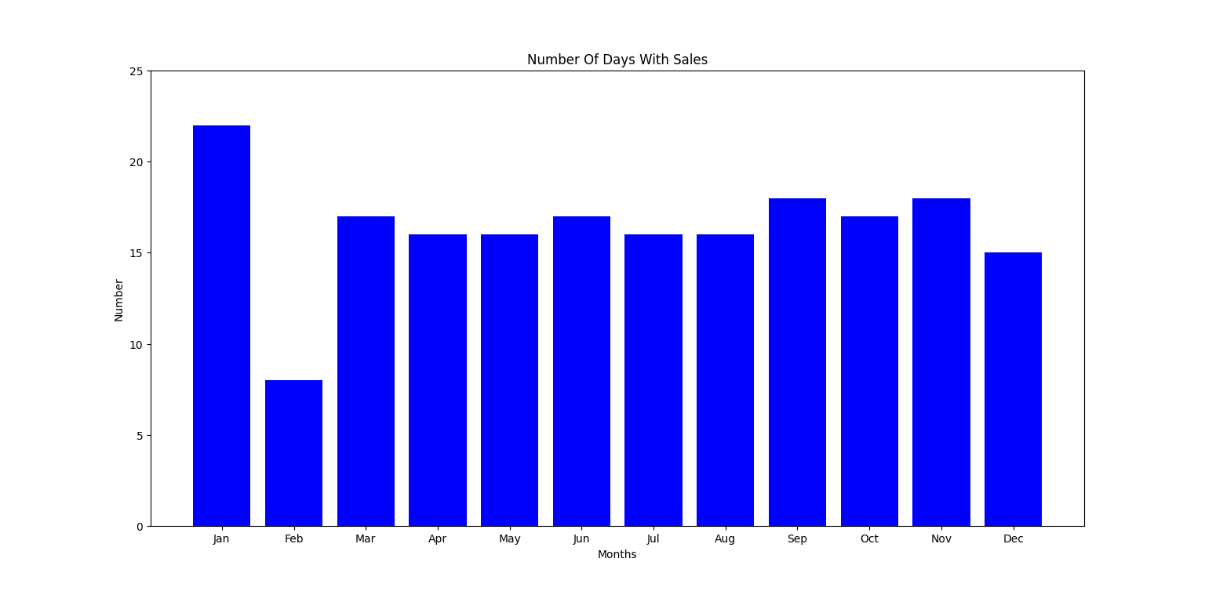
Number of days in each month with sales.

Briefly looking at the number of days with sales in each month, we see that the number of sales is constant throughout the year, however, in February there is a lower amount of active days. This could be either due to holidays when the business is closed or if the business is much less busier. If the latter is the case, then February is a prime candidate for a focused promotion.
January is the busiest month of the year and as such, when planning staffing levels, it would be prudent to ensure there is an adequate number of staff available that month.

Item type (Bike, parts, frames and clothing) by month -

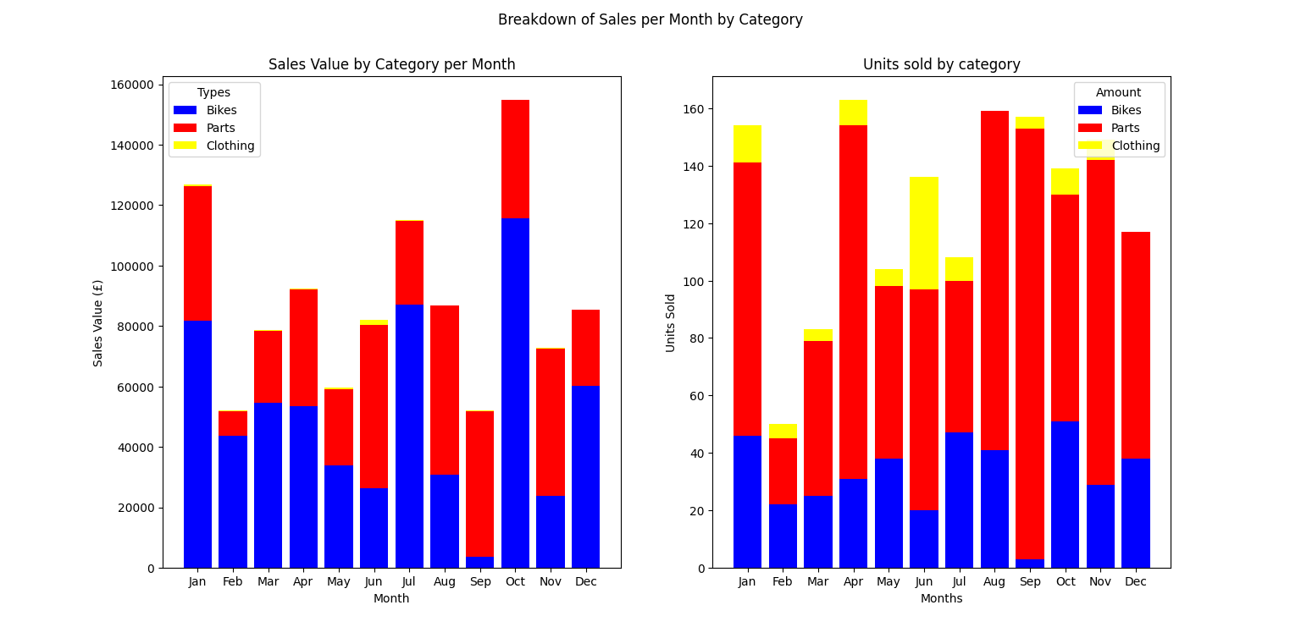Breakdown of sales and revenue by category(bikes, parts and clothing) per month
1 - Dividing by type we see that as predicted, the spike in January is due to sales in bikes, again likely to New Year Resolutions and fitness goals which is mirrored in part by sales in that month (people repairing their bike instead of purchasing a new one for their resolution).
2 - Sales in parts dropped to its lowest in February and increased over the remaining months of the year. Very likely due to demand no longer being strong after January (no need for parts for recently purchased or repaired bikes). Although bike sales still remain modest, likely to be latecomers to the ‘lets get healthier for the new year’ crowd. We have seen that February has the lowest sales and is the month that is potentially the holidays for the business (Staff holidays). This is a good strategy if it is the case as taking holidays during low demand periods is prudent, if this is not the case and the business is open throughout the whole of the month, then February should be THE key area to target for promotional and market campaigns, in particular for parts. In terms of space, this would be a good time to increase the variety of parts sold as going into the summer months.
3 - After the drop in February, bike sales increase incrementally until July, where they peak again and are very likely due to the summer season and the weather being idle for cycling (it being an outdoor activity). However sales prior to this are low and an ‘Early bird’ promotion for bikes could be implemented in June to potentially raise sales.
4 - As mentioned over the summer months, part sales increase much more than bike sales and peaks towards the end of summer. Most likely due to maintenance and upkeep of bicycles as they are used over the summer months. To that end energy should be focused on customers that purchase parts for customers that offer a service to their customers.
5 - Clothing, as mentioned before, is a low revenue generating product. However, the month of June sees a spike in clothing sales. This would suggest that discarding the sale of clothes as too rash and that there is room for clothing sales but it could be possible that the sale of clothing is restricted to the summer months only to reflect the demand. Clothing could be a seasonal item for the summer. This would also allow room for other items to be sold in its place during the other months such as more parts or the opportunity to try new products to the market without affecting existing sales.
6 - The month of September is the worst for bike sales but the best for parts. This is seen as due to the fact that at the end of the cycling season, customers want to repair and fix issues before putting their bike away. This could be an opportunity to upsell new bikes as an alternative to repairing as bike sales produce more revenue per unit than parts.
7 - As expected, sales peak in October and are strong in December due to the Christmas season. Given that the new year is upon us at this stage (and potentially new bike models), this period could be used to move old or going out of production stock, in particular November. If not already doing so, then doing this as a ‘Black Friday’ event could be beneficial.

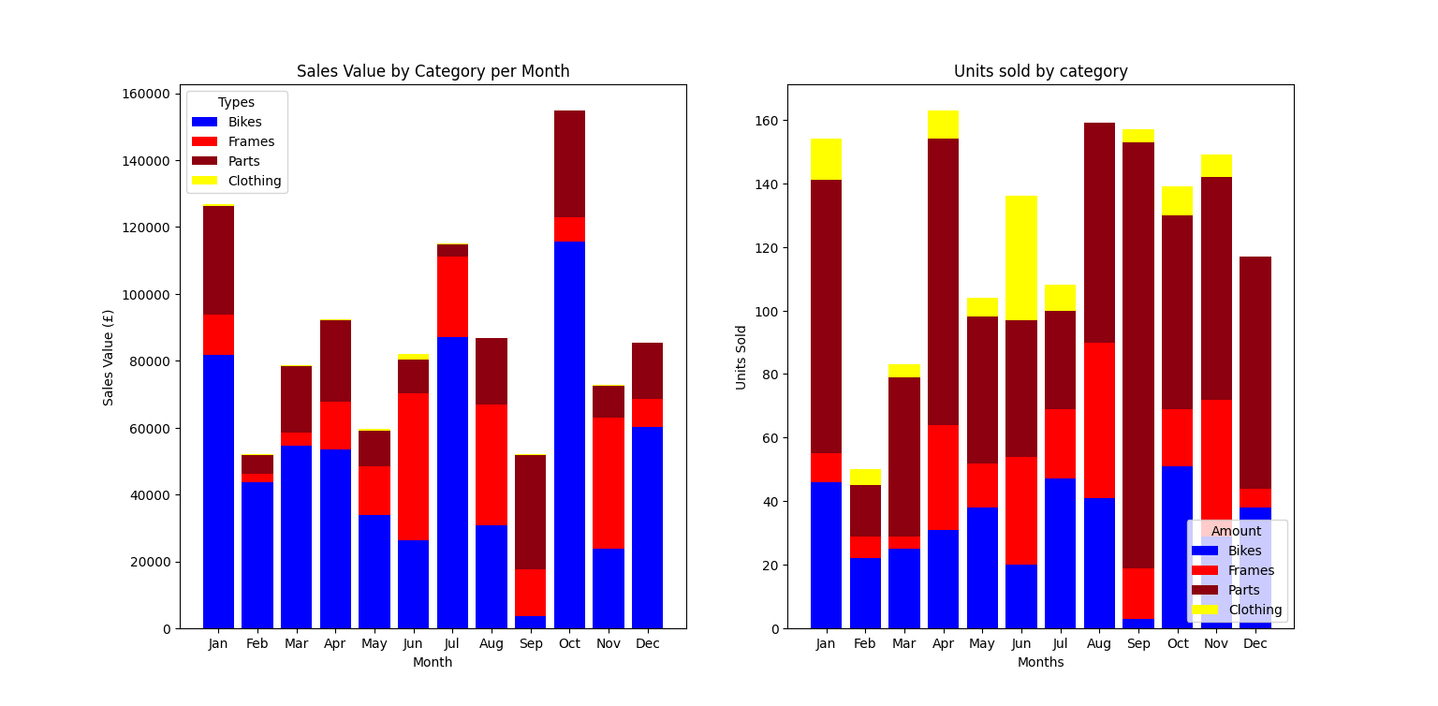
Breakdown by category that now includes frames and parts.

Splitting parts into frames and other parts essentially mirrors the breakdown of bike parts and clothing as before, however there are some subtleties.
1 - First is that over the summer months, bike frame sales increase and generate healthy revenue. This again is likely to be maintenance issues and as mentioned prior, offering bundles of different parts could help further part sales.
2 - Secondly, sales of frames are low over the early months of the year. This indicates that frames are bought mainly in the summer and due to this being a maintenance period, likely sales are replacement sales. This leads to the idea as mentioned that the customer base of the business is those who want a complete bike and those who are repairing. This leaves the notion that a 3rd customer base is left untapped, that is customers who provide a customization service for their customers.

Analysis of bikes and frames by type

Analysing bikes by ‘Mountain’, ‘Road’ and ‘Touring’ types -

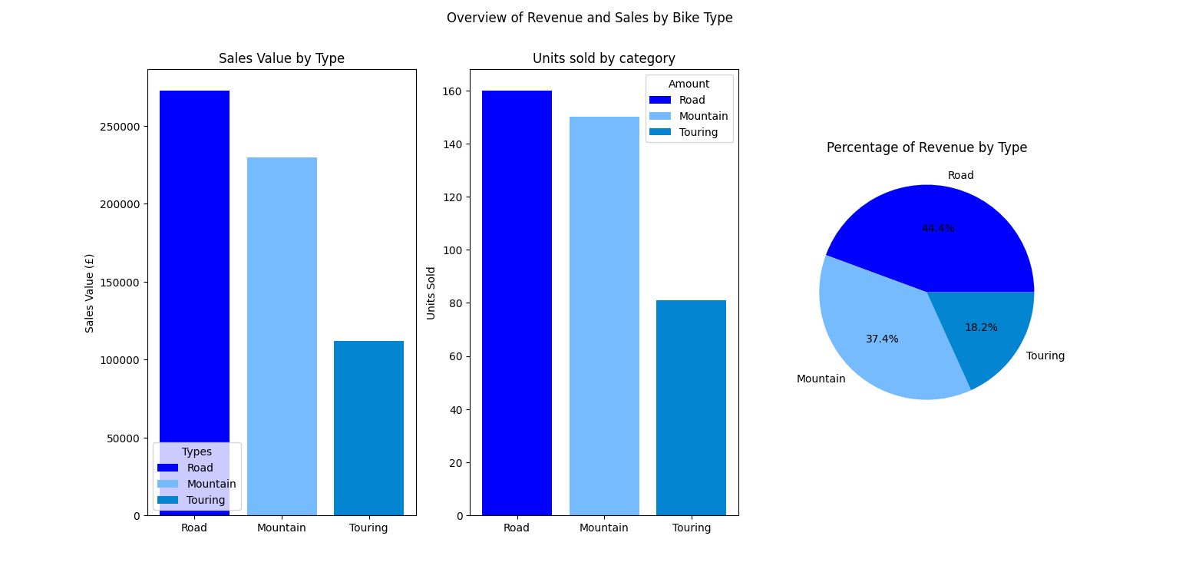
Splitting bikes by type

We see that mountain and road bikes sell at roughly equal amounts, however road bikes produce more revenue. This is to be expected as road bikes usually are more expensive due to the materials used in their production. Touring bikes only sell half as many (or around 20%). This would indicate that road bikes (as evidenced prior) are the biggest generator of revenue of the business. This is their core product line with a very close second being mountain bikes.

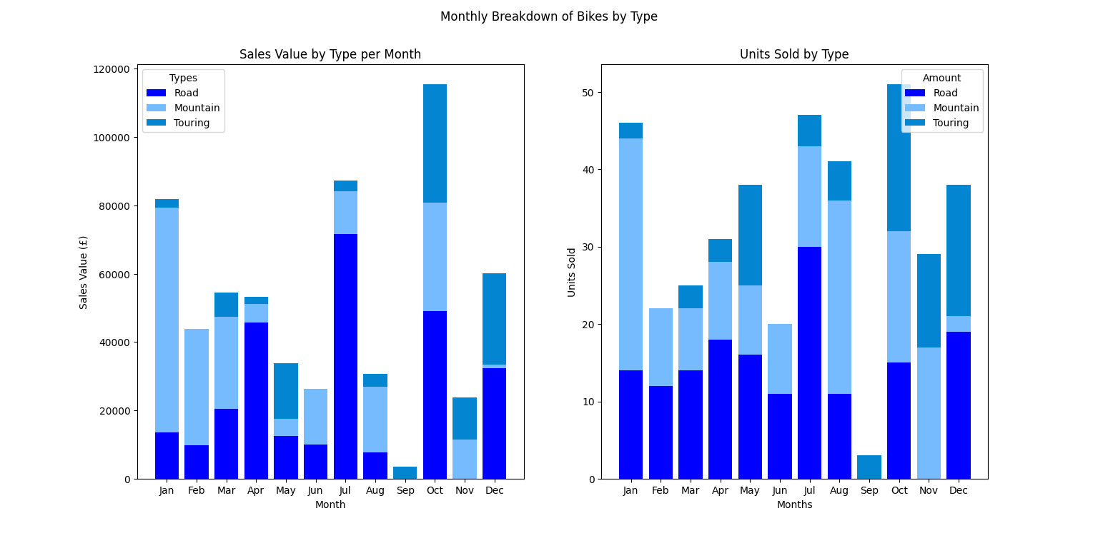
Monthly stats for bike types.

Road -
Breaking down the sales of different bike types by month, we see that not only are road bikes the biggest revenue stream and the item that sells the most, it is also the type that sells the most consistently. 10 out of 12 months have roughly even sales with a spike in July. July also has the largest revenue for road bikes. There are no sales in September, which was mentioned and there are no road bike sales, and there are no bike sales in November. This drop in sales at this time of year could be due to conditions for road cycling not being ideal due to the winter season.
Although there are consistent unit sales of road bikes across the year, there are large variations in revenue. This would suggest that the months of April, July, October and December saw sales in more expensive or premium road bikes.
Mountain -
Unit sales in mountain bikes have spikes in January, August, October and November and mid-range consistent sales from late winter until early summer. This would suggest that most mountain bikes sales arise in the latter part of the year for the business but the biggest revenue for mountain bikes comes from the first months of the year. Reasons could be that at the start of the year, premium bikes sell more whilst towards the end of the year, mountain bikes from the lower range sell. This suggests that, although mountain bikes sell all year round (bar September), there is a dichotomy in sales. Less but more expensive in the first half of the year and more but cheaper in the last 6 months of the year.
Touring -
Touring bikes sell less units and generate less revenue. This may be due to touring bikes being more of a speciality bike, used for travelling (more akin to a holiday or for extended travelling). There are two periods where they sell the most. First is the last quarter of the year (Oct, Nov and Dec), probably due to Christmas. The second is in May. May may be seen as the start of the holiday season and the customers purchasing as such to fulfill demand for the coming months.

Analysing frames by ‘Mountain’, ‘Road’ and ‘Touring’ types -

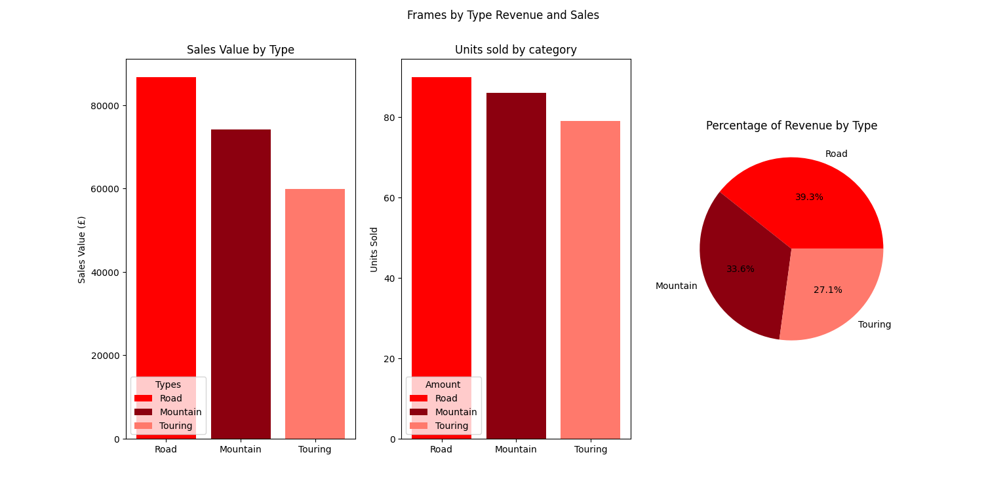
Frames by type

Unlike whole bikes that have 2 dominate types with a lesser 3rd type, bike frames are more evenly distribution for unit sales and revenue, however road bikes are still the leader in terms of revenue by around 15%.

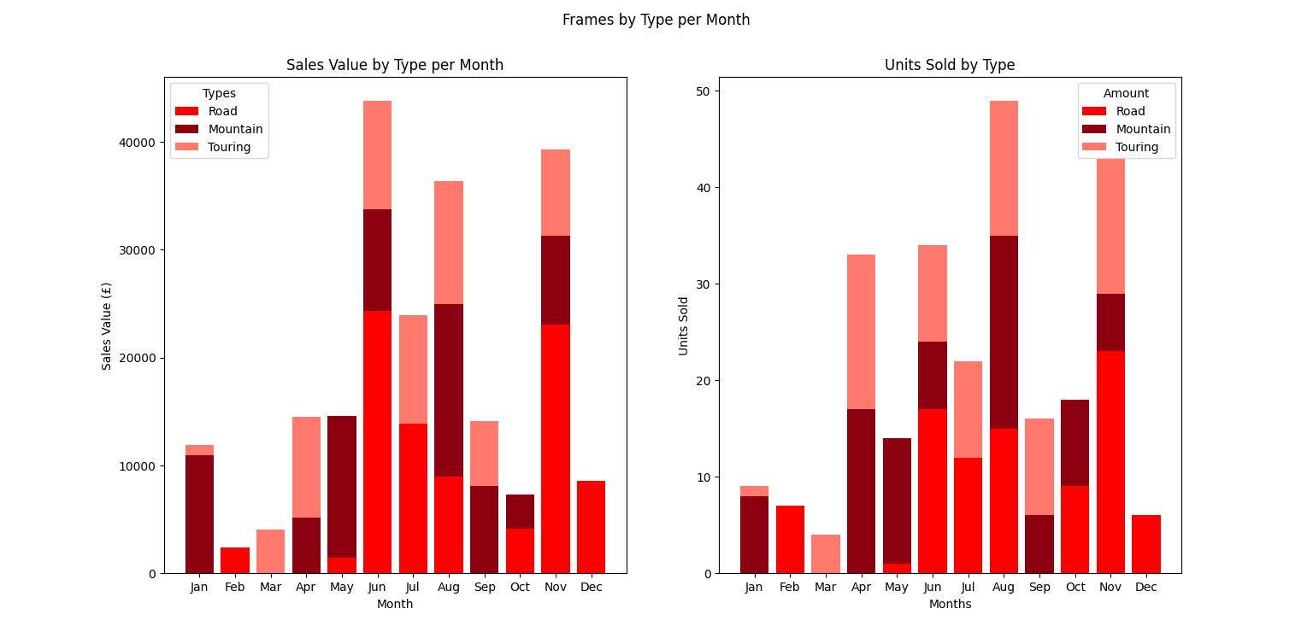
Frame type sales and revenue by type.
The monthly sales of bike frames shows that the majority of the sales for frames happen within the summer months. There is an outlier or spike in November for the sale of frames and along with the month of august, these are when most frames are sold. Given that frame sales are concentrated around April to November and the sales of different types are somewhat balanced, any promotions, special offers or discounts for frames should be placed in the earlier part of the year with no reason to focus on one type or another.

Analysis of customer spending

Analysing spending overall -

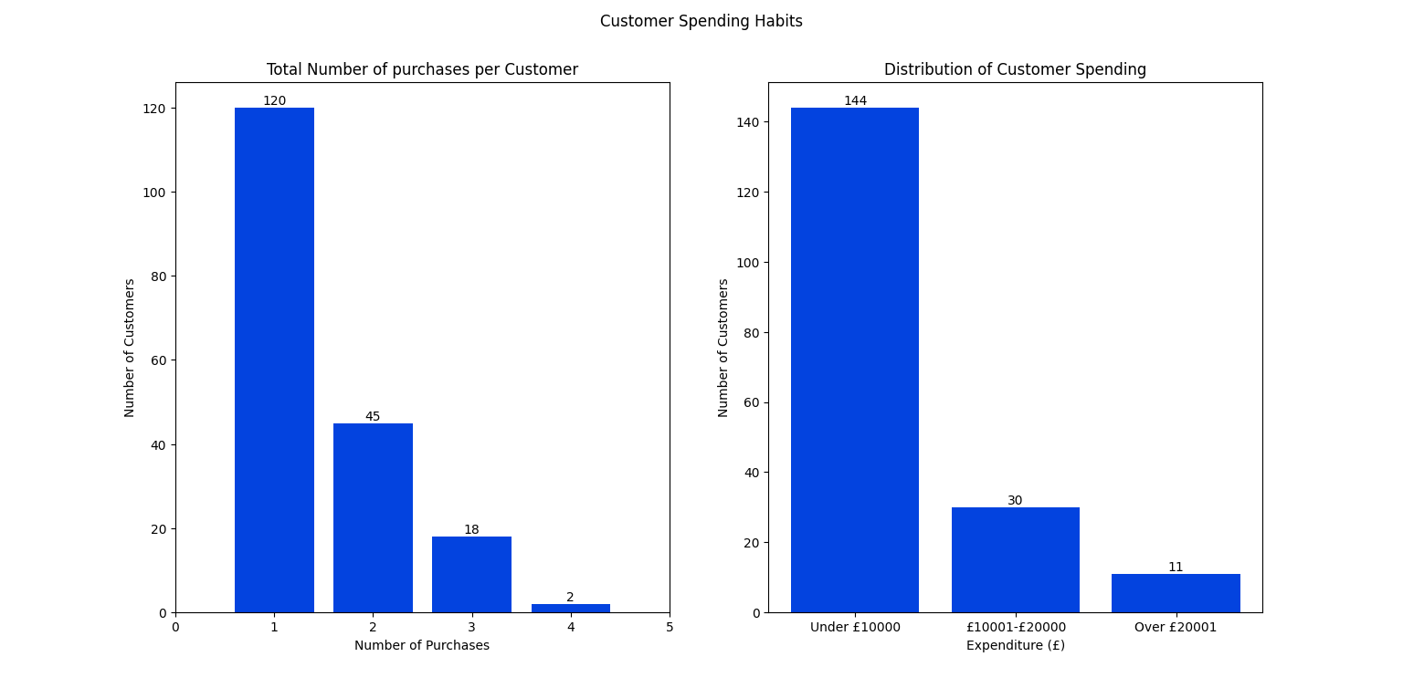
Customer spending habits with spending binned.

We can see that the majority of customers spend under £10000 (144 out of 185) with a small number spending over £10000 and only (11/185) about 6% of customers within the highest spend bracket. Most of the customers only purchase once during the year(average of 1.5 purchases) with only 65 being repeat customers. Of these returning customers, most only return once more, whilst a small fraction can be considered ‘Serial’ customers. Potentially this could indicate that retention of customers could be an issue for the business. A potential answer could be to have a customer tiering system that rewards customers for their repeat business depending on how many different purchases they make and how much they spend. Those who only purchase once and under £10000 do not receive a discount and are at the bottom of the ‘discount ladder’ and discount rate increasing for each purchase and spend level, reaching maximum discount if a customer makes 4 purchases or more AND spends over £20000.

Analysis of spending by type -

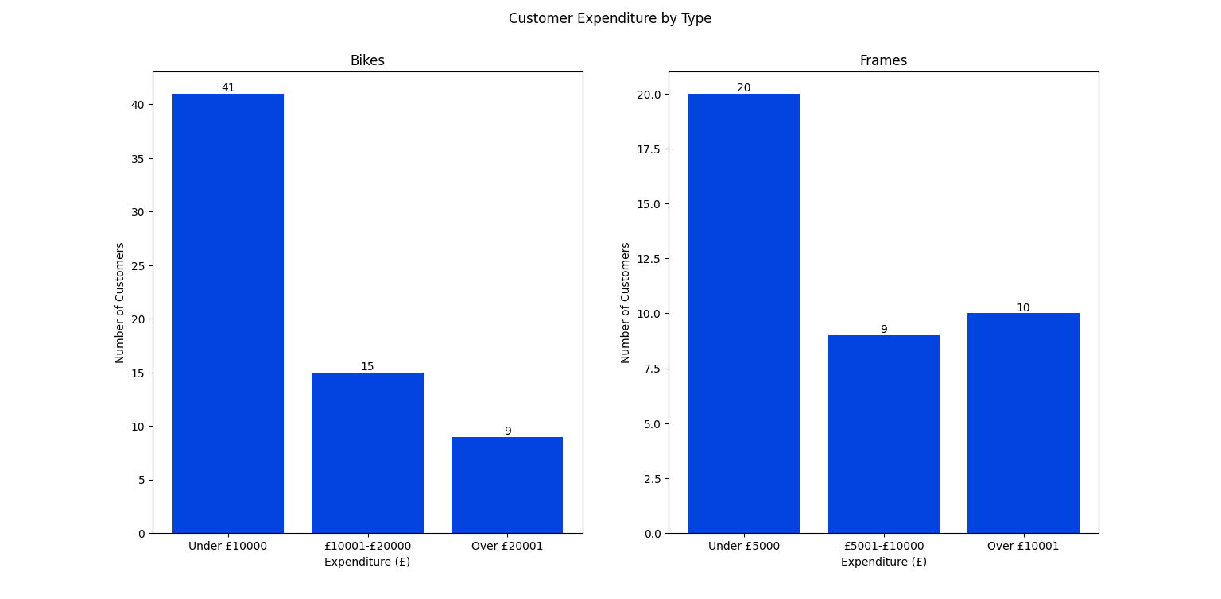
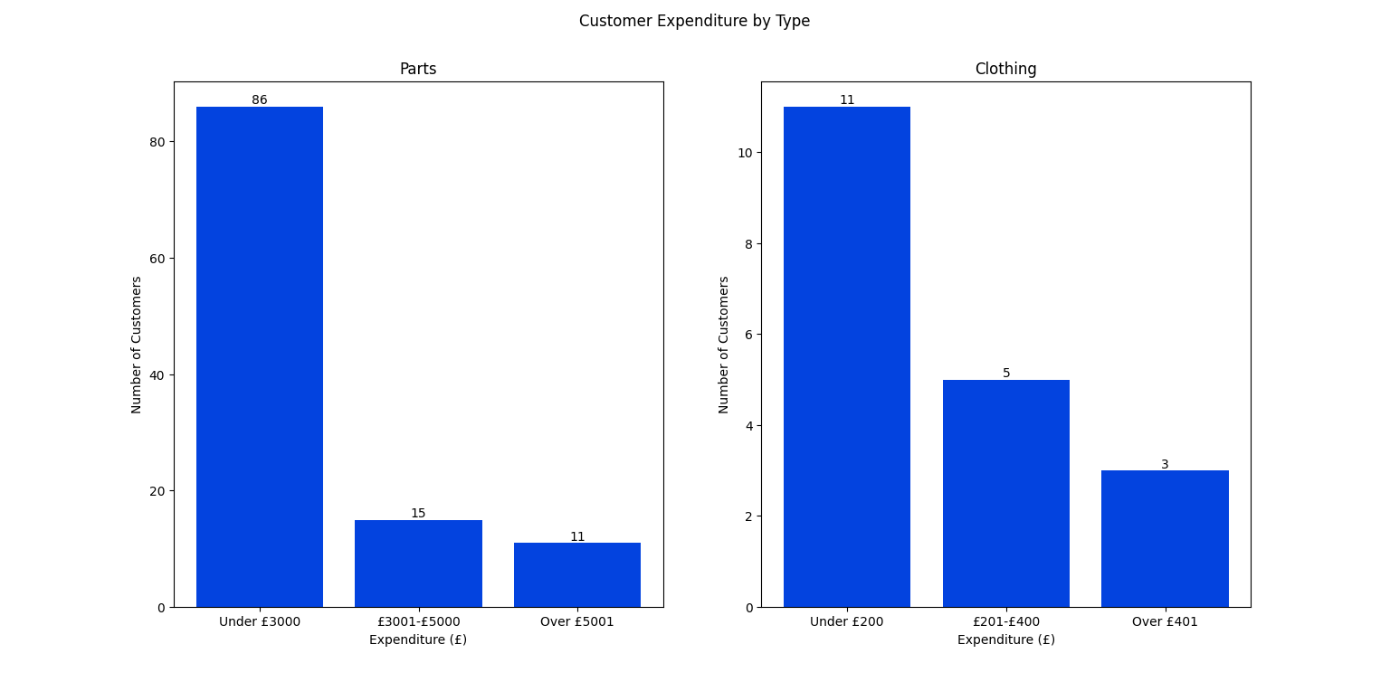
Customer spending on each type of product.

We see that over half of all customers who purchase bikes, spend less than £10000 and that only 9 (14%) of customers who purchase bikes, spend over £20000. Frames produces data that is slightly different in that, again the majority of customers spend under a certain amount (£5000), roughly equal number of customers will spend between £5001 - £10000 or over £10000.
The purchasing of parts has the greatest proportion of sales being at the lower end of the scale, with 70% of customers spending over £3000. This, coupled with many customers only making one purchase, would suggest that many customers come to the business primarily for a specific part but don't return to purchase bikes or frames which are the real profit drivers.
This could be an opportunity or area for the business to capture customer details and actively seek sales in bikes / frames at a future date from these customers. Potentially this could be done through a first time purchase offer for the customer.
Since there are a lot of one time only purchases in terms of type, each type could offer discounts on repeat customers i.e. 10% off their next purchase of frames or clothing items.

